Lab Exercise 26 - Enabling and Using Trace Logs in MinIO

Lab Objective
After completing this lab, you will be able to:
- Understand what trace logs are in MinIO
- Enable real-time tracing using mc admin trace
- Capture S3 API calls and internal MinIO operations
- Filter trace output by operation type
- Use trace logs for debugging performance, access, and failures

Prerequisites
- MinIO server running (single-node or distributed)
- mc (MinIO Client) installed
- Admin credentials
- Shell access to MinIO client machine
- Basic understanding of S3 operations

Lab Environment (Example)
Component | Value
OS | Rocky Linux
MinIO Endpoint | http://localhost:9000
Console | http://localhost:9001
Alias Name | myminio
Bucket Name | trace-lab

Step 1: Verify MinIO Server is Running
minio server /mnt/data --console-address ":9001

Expected:
Active: active (running)

Step 2: Configure MinIO Client Alias
mc alias set local http://15.206.166.57:9000 minioadmin Minio@12345

Verify connection:
mc admin info myminio

Step 3: Create a Test Bucket
mc mb myminio/trace-lab

Verify:
mc ls myminio

Step 4: Understand MinIO Trace Logging
Trace logs capture:
- S3 API requests (PUT, GET, DELETE)
- Client IP
- Object name
- Bucket name
- Request latency
- Error messages (if any)
Trace logs are real-time only and not stored by default.

Step 5: Start Trace Logging (Basic)
Open a new terminal window and run:
mc admin trace myminio

You will see live streaming logs.
Example output:
2026-01-08T11:02:45.123 PUT /trace-lab/file.txt 200 OK
Leave this terminal running.

Step 6: Generate Activity (Another Terminal)
Create a test file:
echo "MinIO Trace Test" > testfile.txt

Upload file:
mc cp testfile.txt myminio/trace-lab/

Download file:
mc cp myminio/trace-lab/testfile.txt .

Delete file:
mc rm myminio/trace-lab/testfile.txt

Step 7: Observe Trace Output
In the trace terminal, you should see entries like:
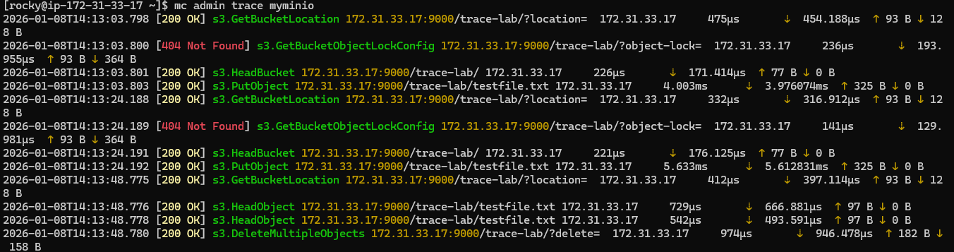This confirms trace logging is working.

Step 8: Enable Detailed Trace Output
Stop current trace (Ctrl + C) and start with verbose flags:
mc admin trace myminio --verbose

This includes:
- Request headers
- Response status
- Latency
- Authentication details
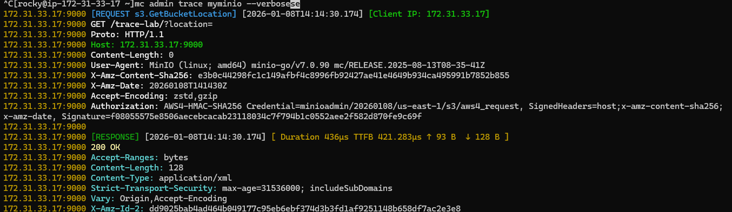

Step 9: Filter Trace Logs by S3 Operations
Trace only ERRORS
mc admin trace myminio –errors
Trace specific HTTP methods
mc admin trace myminio --method PUT

Step 10: Trace and Save Logs to a File
mc admin trace myminio --verbose > minio-trace.log

Run some operations, then stop tracing.
View file:
less minio-trace.log

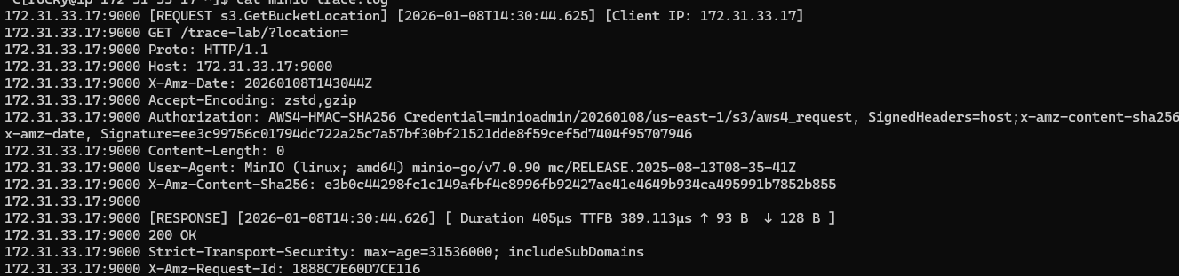

Step 11: Trace a Specific Bucket
mc admin trace myminio –path trace-lab

Only requests related to trace-lab will appear.

